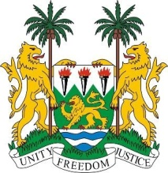
SIERRA LEONE

26th Session of the Universal Periodic Review

HAITI

STATEMENT BY SIERRA LEONE

7 November 2016

Mr President,

Sierra Leone extends a warm welcome to the delegation from Haiti and thanks them for their report and today’s presentation.

My delegation applauds the progress made since the last cycle in 2011, including the ratification and accession to the ICESCR in 2014, the adoption of the Trafficking in Persons Act, as well as the submission of a national mid-term review, all of which, my delegation believes demonstrate the government’s commitment to promoting human rights nationally.

My delegation notes the steps being taken to address the social and economic rights of its peoples and calls upon donors to support such efforts.

Sierra Leone is especially cognisant of the fact that Haiti has suffered from both made-made and natural disasters over the years, including the recent hurricane that swept through the country and we would encourage the government to continue to work with international stakeholders in order to effectively redress the long-lasting impact of the disasters.

Recommendations:

- Ratify and accede to the CAT, ICRMW and the ICPPED.
- Establish a legal framework to better protect women and girls from sexual exploitation and forced marriage.
- Raise the minimum age of marriage to 18 for both boys and girls.
- Establish coordinated disaster risk management strategies and action plan.

To conclude, Sierra Leone wishes Haiti success in the implementation of the accepted recommendations.

Thank you, Mr President.

